ECE60146 Homework 3
Lucas Nguyen nguye800@purdue.edu
1/31/2026
2 Using ComputationalGraphPrimer
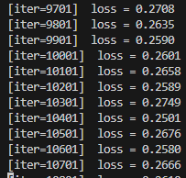
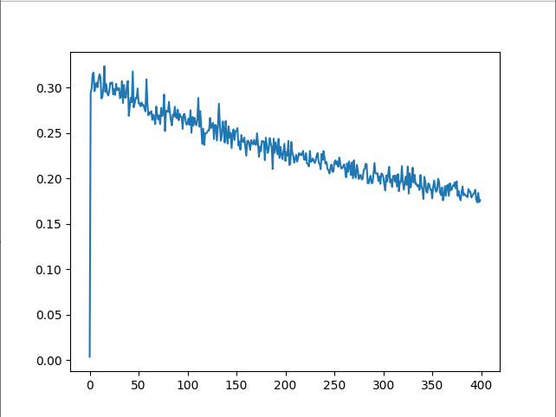
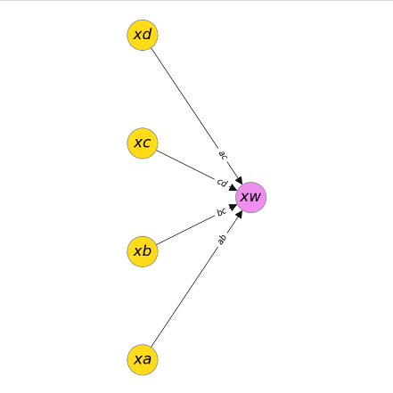
One_neuron_classifier

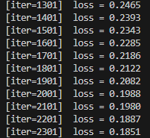
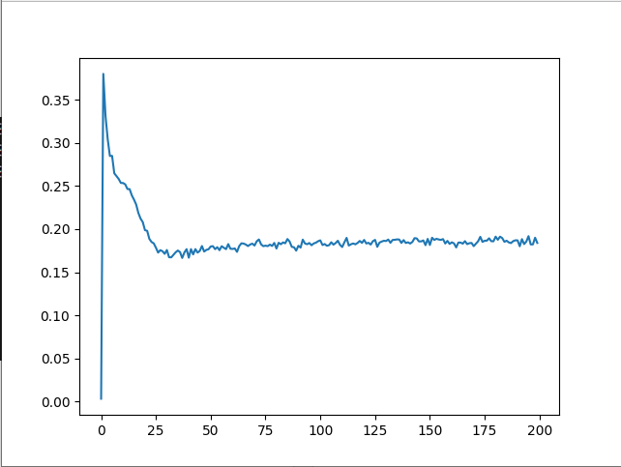
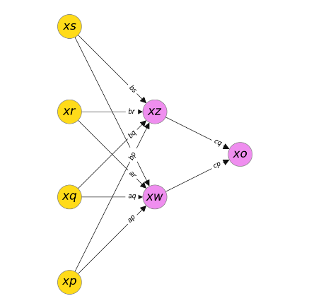
Multi_neuron_classifier

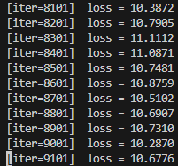
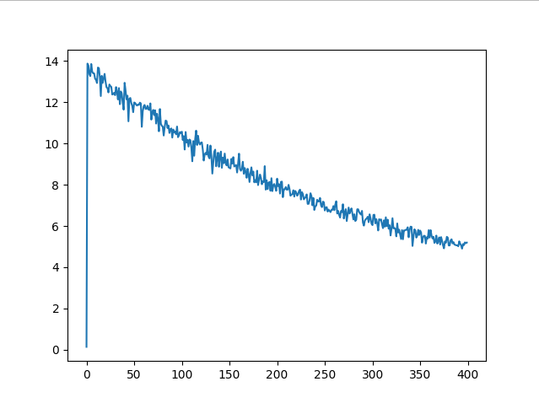
Verify_with_torchnn (multi neuron)
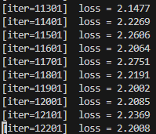
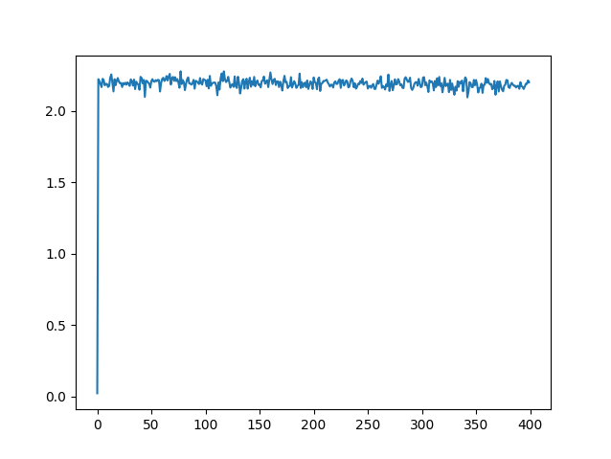
Verify_with_torchnn (single neuron)

Multi_neuron_classifier vs. verify_with_torchnn
The scale factor of the loss functions seems to be completely different for the computational graph primer and the PyTorch version of a multi neuron network. The PyTorch implementation starts with a loss around 14 and finishes between 4-6 whereas the multi neuron network implemented using the computational graph primer starts around 0.35 and ends around 0.15-0.2. Additionally the shape of the loss curve is completely different. The multi_neuron_classifer almost immediately dips to a stable 0.15-0.2 loss within the first 2500 iterations (denoted by 25 in the graph) and fluctuates in place for the rest of the training loop. In the PyTorch implementation the loss curve steadily decreases approximately linearly throughout the entire training loop.

One_neuron_classifier vs verify_with_torchnn
The scale factor of the two implementations again differ largely with the PyTorch implementation loss hovering around 2.2-2.3 and the computational graph primer implementation starting with 0.3 and ending with 0.15-0.2 loss. Additionally, the loss curves of the two implementations are completely different. The one_neuron_classifer has a steady approximately linear decrease in loss over the entire training loop whereas the PyTorch implementation maintains the exact same loss the entire training loop leading to the belief that the parameter was either initialized optimally by chance and didn’t require training or was initialized on an extremely flat loss landscape.

3 Programming Tasks

